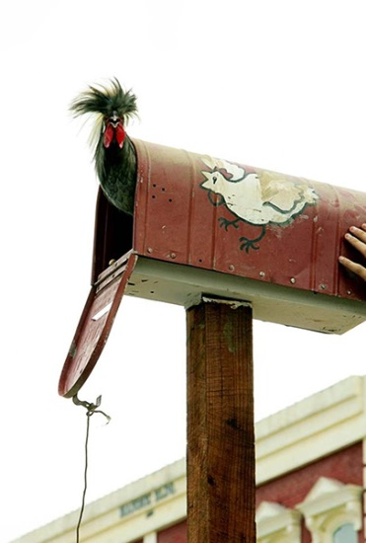
COME & TAKE IT
CHICKEN FLYING CONTEST ENTRY FORM AND RULES
OCTOBER 4, 2014 at 2 p.m.

Name: ____________________________________________________
Address: ___________________________________________________
Age: _______________________
Name of chicken: ____________________________________________
By signing below, I acknowledge I have read and understand the rules.
Signature____________________________________________________
RULES
1. $5 entry fee - must be paid when entry form is submitted.
2. The contest is open to any adult or child who enters a hen or rooster by 1:30pm.
3. NO COMMERCIAL BROILERS OR LAYING HENS.
4. Flights will be made from a pole high perch and distance measured from starting point to landing.
5. Trophies will be awarded for 1st, 2nd, & 3rd longest flight, most original named chicken, and for shortest flight.
6. DECISIONS OF THE JUDGES ARE FINAL.

