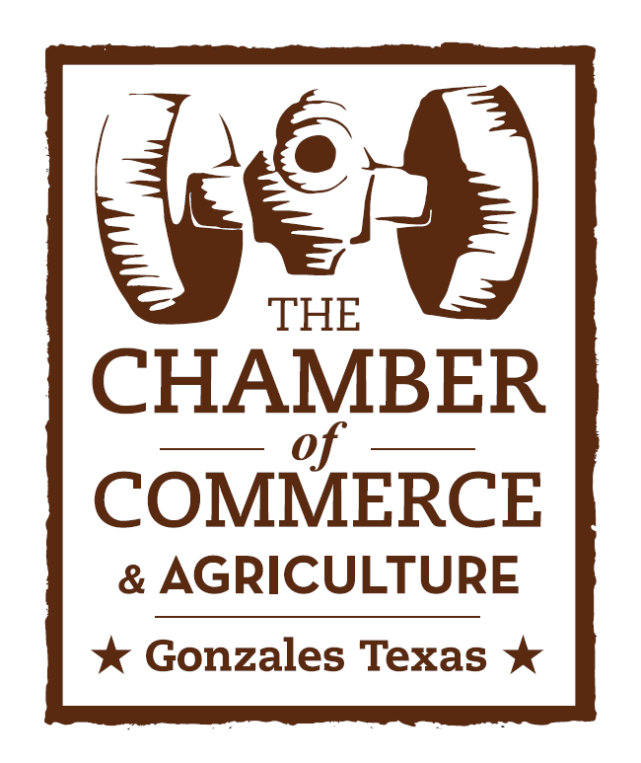
Come and Take It Celebration
Sponsorship Package

Now is your chance to differentiate yourself from the competition by supporting the most historic celebration in Texas!

Our History:

Celebrate “Come & Take It!” with us! The dates for the Come & Take It Celebration are Oct. 3, 4 & 5, 2014. The Come & Take It Celebration celebrates the firing of the first shot of the Texas revolution on Oct. 2, 1835, which took place near Gonzales. Gonzales was established by Empresario Green DeWitt in 1825, two and one-half miles east of the confluence of the San Marcos and Guadalupe Rivers. It was the westernmost Anglo settlement until the close of the Texas Revolution and was named in honor of Don Rafael Gonzales, provisional governor of Coahuila, Mexico and Texas. The town was laid out in the shape of a cross, with seven squares. During the colonial period of 1825 to 1835, there were many problems with Comanche and Tonkawa Indians, but Gonzales flourished. It was a thriving capital of the De Witt colony by 1833.
In 1831 the Mexican government loaned the citizens of Gonzales a six-pound cannon as protection against the Indians. In September of 1835, as political unrest grew, Mexican officials at San Antonio de Bexar demanded the cannon be returned.
A corporal with five soldiers and an oxcart were first sent by Col. Ugartechea, Bexar military commander, to Gonzales. The corporal carried a request that the small reinforced cannon, a bronze six-pounder, be returned to the Mexican Army. Andrew Ponton refused to relinquish it, stalling for time, and the little cannon was buried in George W. Davis’ peach orchard, near the Guadalupe River. Lieutenant Castaneda and 150 mounted soldiers to “take” the cannon. When the soldiers appeared on the west bank of the Guadalupe River, there were only 18 men in Gonzales, but these ‘Old Eighteen’ stood at the river in defiance, denied the Mexicans a crossing by hiding the ferry and sent out a call for volunteers to assist them.
As the soldiers scouted the river for a place to cross, they moved upriver a short distance, near the present-day community of Cost and camped for the night. There, in the early-morning hours of Oct. 2, 1835, the colonists crossed the river with their cannon, surprising the troops and waving their hastily fashioned flag, which proclaimed “Come and Take It.” Almost immediately the cannon fired, killing one of Castenada’s men and scattering the rest, forcing them to retreat to San Antonio de Bexar. Thus was fired the shot that set off the struggle for Texas independence from Mexico. When the smoke cleared, the Mexican troops had taken off. The Texas Revolution had begun.
Gonzales became known as “The Lexington of Texas”, where the first shot was fired, and where the first Texas Army of Volunteers gathered. A few months after the first shot, men and boys from the region would gather in Gonzales, sending the only reinforcements ever received at the Alamo.
Each October, on the first full weekend of October, the citizens of Gonzales gather to celebrate their Texas heritage in a three-day festival called “Come & Take It.”

Come and Take It Activities:

- Annual Historic Parade through Downtown Gonzales
- Vintage Airstream Rally
- Cutting Horse Event
- Historical Programs
- Battle Reenactments
- Live Music
- Biergarten
- Unique Arts & Crafts Vendors
- Come and Take It 5k Run
- Chicken Flying Contest
- Food Eating Contest
- Canoe Race
- Pride of Texas Carnival
- Camera Club Photo Contest
- Gonzales Art Group Show
- Come and Take It Square Dancing
- Bingo
- Fire Spinning Show
- Texas T-Bone Cook-off
- Texas Bean & Chili Cook Off
- Memorial Services
- Food Booths
- Classic Car & Motorcycle Show

Sponsorship Levels
Immortal 32 Sponsors:
- Immortal 32 Cleanup & Security Sponsor: $2,500
  - Your logo will be posted on barricades, restroom stalls and cleanup crew shirts
- Immortal 32 Biergarten Tent Sponsor: $2,500
  - Your logo will be featured in the biergarten tent area
- Immortal 32 Food Tent Sponsor: $2,500
  - Your logo will be featured in the food tent area
- Immortal 32 Restroom Trailers: $2,500
  - Your logo will be placed on a vinyl or poster graphic on the side of the restroom trailers
- Immortal 32 Tables & Chairs Sponsor: $2,500
  - Your logo will be featured under the biergarten and food tent area
Immortal 32 sponsorship includes the following benefits:
  - Your business logo in 10,000 plus Come and Take It Celebration brochures and promotional posters
  - Your business included in public address announcements which will be scheduled throughout the celebration
  - Your business recognized on all social media outlets (Facebook, Pinterest, Instagram, and Twitter)
  - Your business will be recognized in the Chamber Chatter Column and radio program
  - Your business logo displayed in prominent locations on the celebration grounds
  - Autographed Come and Take It Poster from the live entertainment
  - Logo on our website
  - Complimentary Food and Beverage Tickets
  - Free entry into the Historic Come and Take It Parade
  - Your business will be featured on promotional items handed out during the festival
The Texan Sponsor $2,000
- Your business logo in 10,000 Come and Take It brochures and promotional posters
- Your business included in public address announcements
- Your business recognized on all social media outlets (Facebook, Pinterest, Instagram, and Twitter)
- Your business to be recognized in the Chamber Chatter Column and radio program
- Your business logo displayed in prominent location on the celebration grounds
- Complimentary Food and Beverage Tickets
- Autographed Come and Take It Poster from the live entertainment

Lone Star Entertainment Sponsor $1,000
- Your business logo on the stage area
- Your business logo on koozies or other promotional items handed out during the weekend of the celebration
- Your business logo on 10,000 Come and Take It brochures and posters
- Autographed Come and Take It poster
- Recognition on our website, newspaper, and social media outlets
- Your logo on our website
Cannon Ball Sponsor $500
- Your business logo on koozies or other promotional items handed out during the weekend of the celebration
- Your business logo on 10,000 Come and Take It brochures and posters
- Autographed Come and Take It poster
- Recognition on our website, newspaper, and social media outlets
- Your logo on the Gonzales Chamber website
Pioneer Sponsor $250
- Your business logo on 10,000 Come and Take It brochures and posters
- Recognition on our website, newspaper, and social media outlets
- Your logo on the Gonzales Chamber website

Spark Sponsor $25
- Your name or business will be mentioned in the Chamber Chatter and radio programs
- Your name will be listed on Facebook and other social media outlets

Thank you for your support!
Let’s Come and Take It!
For General information please contact the Gonzales Chamber of Commerce & Agriculture at 830.672.6532.

Administrative Assistant: Admin@GonzalesTexas.com
Executive Director: CTI@GonzalesTexas.com

Find us online at www.GonzalesTexas.com
Facebook: www.facebook.com/Comeandtakeitcelebration
Twitter: www.Twitter.com/comeandtakeittx
Pinterest: www.Pinterest.com/comeandtakeittx
Instagram: www.Instagram.com/comeandtakeittx

Address:
Gonzales Chamber of Commerce & Agriculture
414 St. Lawrence
Gonzales, Texas
78629

Please submit the following information to the Gonzales Chamber of Commerce & Agriculture.

Name:
Address:
Email:
Phone Contact:
Choose a package:
- Immortal 32 Sponsor Cleanup & Security
- Immortal 32 Biergarten Tent
- Immortal 32 Food Tent
- Immortal 32 Restroom Trailer
- Immortal 32 Tables & Chairs
- The Texan Sponsor
- Lone Star Entertainment Sponsor
- Cannon Ball Sponsor
- Pioneer Sponsor
- Spark Sponsor

Please make checks payable to:
Gonzales Chamber- Come and Take It Committee

All sponsorships are due by July 31, 2014.

